**Please help keep our Wastewater Treatment Plant Running effectively.**

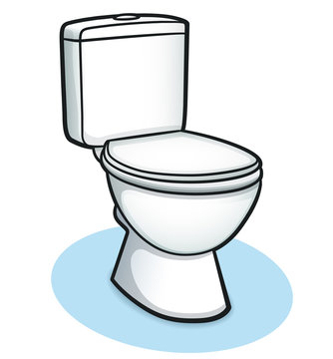**We are asking that you DO NOT flush**

**or put any of the following items down**

**the drain in order to keep our treatment**

**plant operating properly and our drinking**

**water clean!**

**Medications – both over the counter and prescription, there is a medication drop box available in the village hall.**

**Kitchen Waste – grease, cooking oil, coffee grounds, peanut butter.**

**Diapers – cloth, cotton, paper, plastic or disposable.**

**Cigarette Butts**

**Personal Care Products – sanitary napkins, tampons, condoms, panty liners, wipes (no wipes are flushable!!)**

**Trash & Scrap - cotton swabs, dental floss, garbage**

**Kitty Litter – no brand is flushable.**

**Chemicals - photo chemicals, paints, thinners, oils, varnishes, pesticides, used motor oil.**

**Dirt**

**Toys and other items not meant to be flushed.**

**\*\*Sump pumps are not to be connected to the sanitary sewer system per village ordinance §282-33.**

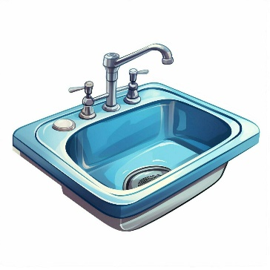[**www.bluemoundsvillage.com**](http://www.bluemoundsvillage.com)